DOMAIN NAME COLLISION ISSUES
ASSOCIATED WITH NEW gTLDs

What is the “name collision” issue in a nutshell?

ICANN is in the process of issuing over 1000 new gTLDs, or ‘generic top level domains’ in the coming months. While this creates many opportunities for innovation in the use of the DNS, there is also the possibility that names in a highly trusted local name space will unexpectedly start routing to unknown external hosts as new gTLDs, and second-level names in those gTLDs, delegate.

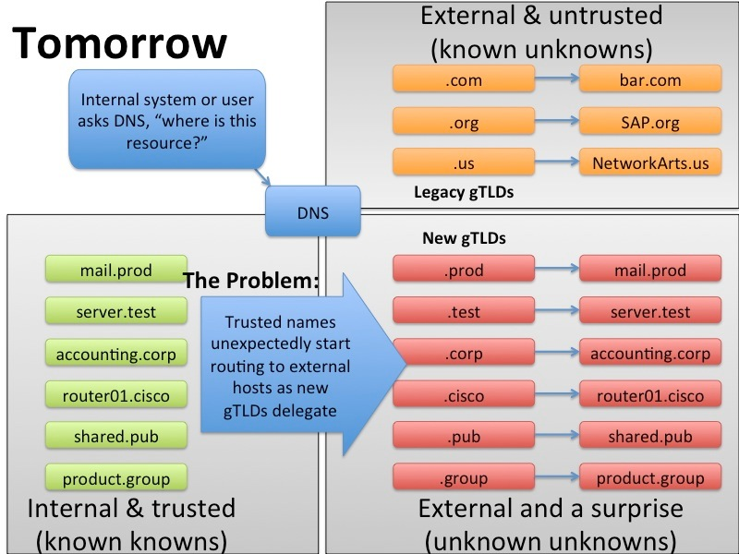

Why is this important to Internet Service Providers?

Your Customer Service Center may receive calls and complaints related to domain name collision issues. You should try to be in a position to understand the problem, and respond knowledgeably to your customer. Here are a few scenarios to consider:
- A bad actor acquires a 2nd-level name and harvests error traffic that is escaping local networks
- An old application is hard-coded to expect an NXDOMAIN response from the root and fails when that behavior changes
- Hardware has a newly-delegated name imbedded in firmware that is difficult to modify or update

This problem may manifest itself in a number of different ways, with events spread out over a number of years as second level delegations come. This is also an issue that doesn’t have a single resolution that will address every issue that might arise, nor is there consensus around what types of systems may break. Broad awareness is our best tool to prevent or mitigate this problem.

What You Can Do

- Education and awareness raising are key to preparing for this issue. Getting the word out to your Customer Service Centers is vital. ICANN has issued a Guide to Name Collision Identification and Mitigation for IT Professionals which should be looked over: https://www.icann.org/en/about/staff/security/ssr/name-collision-mitigation-05dec13-en.pdf
- There are a number of stakeholders looking into different methods of pre-delegation testing, and data gathering from DNS resolvers and the global root to attempt to solve problems before they occur. If you are motivated to assist in this process, leadership in the ISPCP can assist you in connecting you to various groups to help the global effort to minimize the overall impact of domain collisions.
- Go to the ISPCP web site to learn more about this issue – www.ISPCP.info/gTLD-Collisions
- Sign up for the ISPCP weekly “Delegations” email bulletin – www.ISPCP.info/Delegations
- Visit the ICANN name-collisions help page – www.ISPCP.info/icann-collisions-help

