Following the publication of ICANN’s Draft FY17 Operating Plan and Budget, the GNSO Council welcomes the opportunity to provide comments and feedback through ICANN’s Public Comment Forum.
This statement, although on behalf of the GNSO Council, has not been submitted following a formal motion and vote, but is being submitted in the absence of any objection from members of the GNSO Council. These comments are intended to complement any input that may be provided on the FY17 Budget by GNSO Stakeholder Groups and Constituencies.
At the request of the GNSO Council, a group of Councilors reviewed the draft FY17 budget and examined the proposed budget allocations, focusing especially on whether resources directed at policy development seem appropriate, both in relation to the GNSO’s current workload, but also in view of any planned policy activities for FY17.
Based on this review, the GNSO Council would like to provide the following feedback:
General Comments:
- As for the process of FY17 Budget review, the GNSO Council notes that significant improvements that have been made over the last few years with ICANN providing increased transparency and detail in both the budget and operating plans. We thank ICANN for their efforts in this regard.
- We note the proposed increased responsibility going forward of the community, and specifically of this Council and Supporting Organization, for budgetary matters as contained in the 2 April 2016 draft Bylaws proposal. This is particularly illustrated by sections 22.4 (budget) and 22.5 (operating proposals) and by Annex D, articles 2.1 (f) and 2.1(c) and Annex E of said proposal. The empowered community will now have the power to reject budgets and operating plans once these have been proposed by ICANN.
- In light of increasing community responsibility for the budget it is our view that there are still further transparency enhancements that need be implemented going forward so that we may properly discharge our new responsibilities in an informed fashion. As such it would be extremely helpful if in future years ICANN would provide:
  - A comparative spreadsheet listing line item amounts budgeted not only for the coming year but also for the current fiscal year's budget, along with enumeration of the percentage difference in funding for particular line items between years,
  - Expenditure breakdowns of particular ICANN divisions, if available (for example, one place to find the total budgeted amount for ICANN Legal across all mission areas),
  - Concrete examples of budgeted items and more granularities letting the community know where and how funds are being spent in specific terms. For example, ICANN funded a portion of the Institute of Internet Diplomacy at the University of Southern California. It is not clear where that expenditure would appear in the budget.
  - FTE numbers also at a project line level rather solely at the portfolio level.
- The GNSO Council Development Session has been funded the last three years as a pilot as part of the special community budget requests. As the evaluation of this pilot has clearly demonstrated the benefits, the GNSO Council welcomes that this project has now moved into the general budget and as a result has graduated from a pilot into a permanent feature. The GNSO Council fully supports this move and thanks ICANN for their continued support.
- The GNSO Council is of the view that it would be helpful if information is made available at the project level of the draft FY17 Budget for FTE numbers by projects rather than by coded descriptions of a more general nature.

Staffing:
- The GNSO Council takes notice of the $1.1M increase in FY17 at 30 FTE for the 1.3 Goal which we understand to be dedicated to policy development and support with ICANN. We support this increase in FY17 but concern still exists as to whether this is enough. The GNSO has recently commenced work on three extensive PDPs (gTLD, RPM, RDS), in addition to other ongoing projects. We anticipate these being multi-year efforts, not including other issue deliberations outside of the GNSO for which we participate. The Council will continue to collaborate with Policy staff to understand if the resourcing is adequate.
  - Note a discrepancy on p.10 of budget that shows no net increase at 30 FTE at $10.5M from FY17 to FY16 Forecast. However, project level spreadsheet shows 33.2 FTE. Note also that the project level shows a total of $10.7M. Approved FY16 Budget Summary did show 29FTE, so if 33.2 FTE is the accurate number and not the summary number, this equates to 3.2 FTE increase for FY17. Please confirm what the total planned FTE is for Goal 1.3.
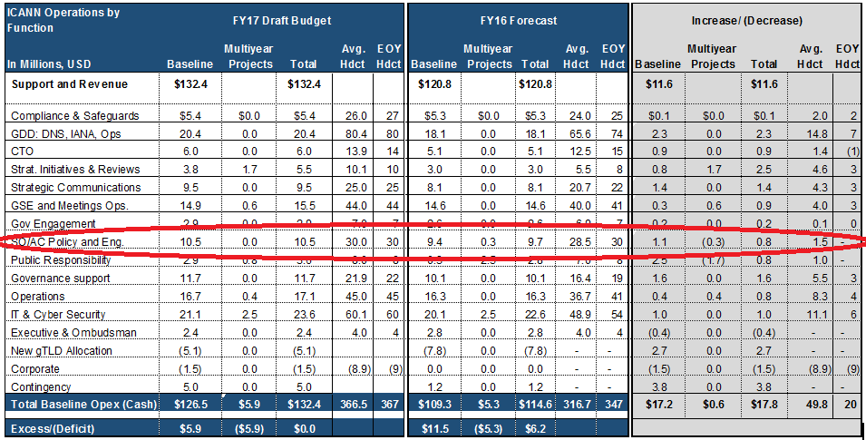
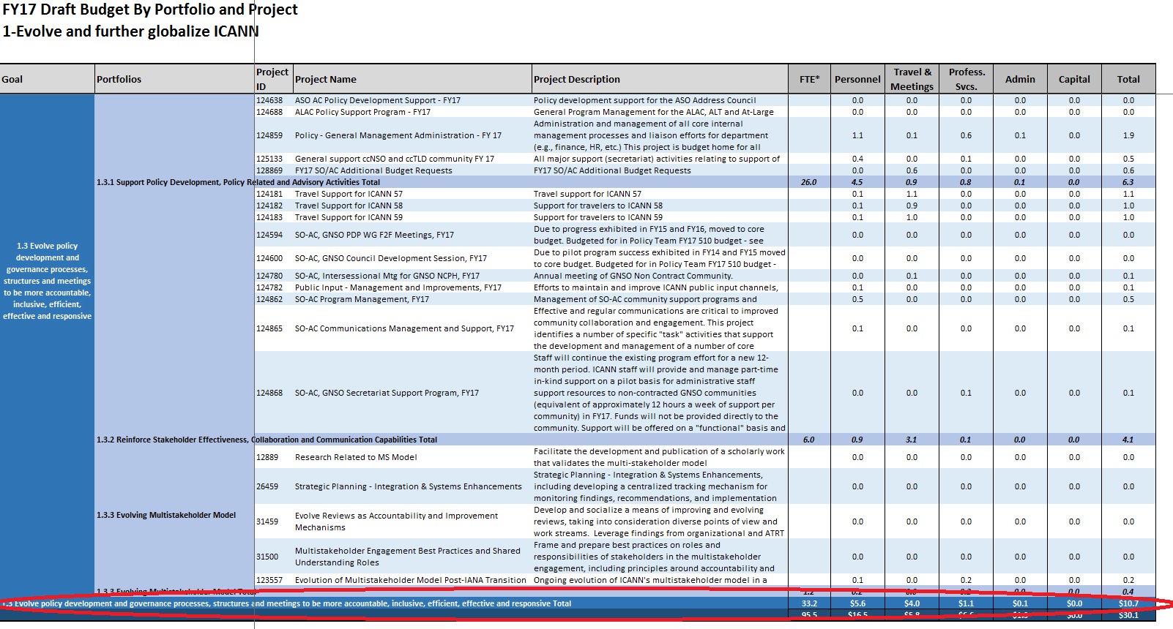
- Conversely, the Council takes notice that in support of Goals 1.1 & 1.2, believed to be devoted to ICANN’s engagement activities, is nearly twice the size in both FTE and dollar amounts to Goal 1.3. The GNSO Council fully supports the requirements for global engagement, but we also recognize that this function is relatively new for ICANN with just over a $19M annual budget. The Council also takes notice of very little interactions with the GSE to date (such as during weekend ICANN meetings) and intends to increase near-term collaboration to better understand the execution of the global engagement’s goals and objectives for the organization and how these support the core functions of ICANN such as policy development activities. We take interest in the success of the engagement activities, because we recognize that we are on the receiving end of recurring participation growth. As it relates to the review of the FY17 draft budget, the GNSO seeks greater insight at the project level for engagement activities. This is an extension of the types of requests made by GNSO stakeholders at ICANN55.
- In the same light, the Council would like further information about the activities of Governance Support, as it budget also exceeds that of SO/AC Policy and Engagement.

Specific Projects – Comments & Questions:
- The GNSO Secretariat Support Program continues to exist as in kind support and as a separate line item. Is the program still under evaluation, is there consideration of moving it to a permanent portion of the budgeting process and if so when?
- The Council wishes to recognize the support for the F2F PDP WG meetings Project and now properly allocated to the core Policy Team budget.
- Group Signup & Activity Management (continuation of Kavi Pilot during DMPM WG) – The Council notes that this is not listed within the multi-year projects. Is this allocated elsewhere in the budget for IT or Policy Development? The GNSO understand the tremendous value of a centrally managed tool that will organize and measure working group activities across the community. Not only will it enhance group management, but it will allow SO/AC leaders to better understand community resource utilization and allocation. This will be an invaluable tool to begin to address issues with community volunteer fatigue.
- The Council notes that each fiscal year, both the CPH and NCPH have annual retreats (CPH within GDD & NCPH within Policy), and the monies spent has been a recent topic within the GNSO.
  - Goal 1.3 – Project 124780 - $100,000 for NCPH Intersessional
  - Goal 2.1 – Project 124349 - $400,000 for GDD Summit
- DMPM Pilot (SO/AC Special Budget Request) – The GNSO Council submitted within the Special SO/AC Budget request to fund a GNSO Council approved pilot on certain requests for data and metrics for policy making. This request was more an advertisement than a request expected to be approved there. First, the Council feels that this type of requests does not meet the original intent of what Special SO/AC budgets requests and therefore we do not want to have those funds consume it. More importantly, the Council feels that the funding of special requests for data and metrics should be a part of the normal Goal 1.3 budget. To ensure that funds are available, the GNSO Council prefers to see a project level budgeted line item to meet the needs of the DMPM pilot. Should the pilot succeed, it can then be determined whether this remains an individual line item, or absorbed and allocated under the core policy budget.

IANA Stewardship Transition (CWG, CCWG, IFO, etc):
- The GNSO Council will defer to its Stakeholder Groups for specific comments as it relates to details about Section 4 Budget for implementation of the IANA Stewardship Transition. The GNSO Council looks forward to engagement with the proposed projects cost support team to assist staff and the ICANN Board to better define future project costs as well as appropriate funding.

The GNSO Council looks forward to receiving a response to the questions and discussing the issues raised in this comment further.

####

[Clarifying Questions Prior to Submission (send to controller@icann.org):
[**Section to be deleted prior to formal submission.]
- Question 4.2.1 and GAC engagement is being classified as external, rather than internal, support. Should GAC not be treated the same as other SOAC's? In the noncommercial community there are a number of members throughout the world that could benefit from this type of treatment through the NCSG. Other SG's likely have the same situation. Why the special treatment for the GAC?
- Some of the "Empower Current and New Stakeholders to fully participate in ICANN Activities" budget lines are...questionable. A zero budgeting for 124156 - Remote Participation. NextGen receiving twice the funding of the 'ongoing' Fellowship program? Where is the $200,000 going to a "gender diversity" program being spent?
- What is the justification for spending triple the amount of money in some regions for Regional Engagement as in others (Asia v. NA)?
- In relation to the ICANN Technical University, What is the purpose of the ITU and where is it situated within ICANN?
- There is the promise of a top 15 projects list to be published by March 31st. Has it been sent? . Depending upon how it is compiled it may be very useful.
- On page 13 of the FY17 Draft Budget, we note a $2.4M decrease in Registrar Accreditation Fees from the FY16 Forecast. Can you please explain the root cause of this assumption?
- P. 14 & 15 – Is there a roadmap for the salesforce.com implementation and Public Responsibility costs for ongoing baseline costs?
- P. 30 - What was the reason for the FY16 Expense decrease of $13.5M from prior (Mar 2015) to current estimate (Feb 2016)?
]

The Council also understands that of the $10.7M Goal 1.3 budget, that $3M devoted to Travel & Meetings for both staff and supported community members. Thus, roughly 70% is devoted to actual policy development.

