2016 Nominating Committee Report Card #2
November-December 2015
Date: 14 December 2015

- Advice from the ICANN Board and from other bodies

One of the main tasks of the Nominating Committee at the beginning of its work cycle, is to reflect on the needs of the ICANN bodies where it will select members, including the existing and desirable skill sets in each of them. The basic advice from the Board in this regard is contained in “Advice from the ICANN Board on Board Skills to the Nominating Committee”, available at the NomCom website.

In order to update and discuss that advice, the 2016 NomCom had a teleconference with ICANN Board Governance Committee (BGC) on 24 November 2015. Issues discussed included alternate paths to the membership of the Board (appointment by a SO or selection by NomCom) and ensuring the continued presence of certain skills on the Board. In general, NomCom members were keen on getting a concise summary of the skill sets the Board feels it currently has. This discussion is likely to continue at subsequent interactions between the BGC and NomCom.

There was a discussion on what constitutes conflict of interest (CoI) for a member of the Board and how the NomCom should take that into account. The message from the BGC was the NomCom should select the best candidates and let the Board worry about CoI when such situations arise; such cases were certainly numerous during the new gTLD process but might be less frequent from now on. However, the overall guidance given in the Bylaws, notably Art. VI, Sec 3.1 should always be kept in mind.

The time commitment necessary for members of the Board was discussed. There was a consensus that the official guideline of 20 hours/week is too low, and that Board members should be prepared to double the time commitment in order to be effective. In other words, combining service on the ICANN Board and having a life elsewhere – professional or private – is becoming increasingly difficult.

- Outreach

Outreach to spread information about available leadership positions and to arouse interest in them is one of the main activities of the NomCom in the current phase of its work cycle. Coordinated by the Outreach Sub-Committee the 2016 NomCom has created a calendar of outreach opportunities at major internet-related events around the world, as well as information material to be used.

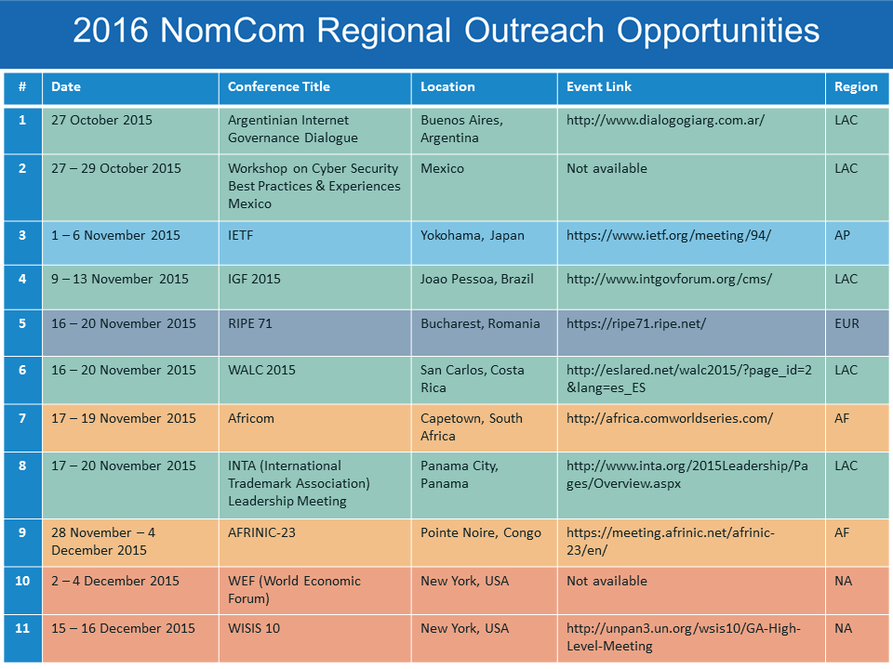
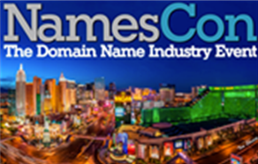
The Chair of the 2016 NomCom is going to participate at NamesCon, a major domain industry event, in Las Vegas, Nevada, 9-13 January 2016. A NomCom advertisement has been prepared for inclusion in the NamesCon program brochure.

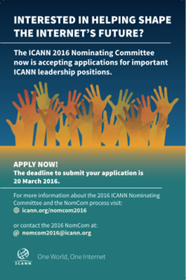

- External assistance

Successive NomComs have used external expertise in assessing top candidates for the Board since 2008, and for recruitment (“head-hunting”) since 2013. The former function has been carried out by the Frankfurt office of Odgers Berndtson (OB), a global executive search firm, the latter by the Brussels office of the same firm. Total separation is maintained between the two OB offices as far as their work for NomCom is concerned.

At the kick-off meeting in Dublin, 2016 NomCom decided to review the question of external assistance as a whole, and created a Recruitment/Evaluation Vendor Sub-Committee for that purpose. After initial contacts by the NomCom Chair, a representative of OB-Brussels was invited to attend the NomCom meeting December 8 to present various options for the future cooperation between OB and NomCom.

The Recruitment/Evaluation Vendor Sub-Committee met 10 December. After considering the options suggested by OB Brussels and further discussion on other options, the sub-committee decided to propose to the full 2016 NomCom that it maintain last year’s process, with clear division of labor between OB-F and OB-B, to avoid taking any decisions in a hurry and with limited information.

For the next year, the Sub-Committee will work on considering various options with the benefit of more information and time and provide recommendations for improving the process the following year.

Appendix: 2016 NomCom essentials

Leaders to be selected

- Three members of the ICANN Board of Directors
- Two At-Large Advisory Committee (ALAC) members (one each from Europe and North America)
- One member of the Council of the Generic Names Supporting Organization (GNSO)
- One member of the Council of the country code Names Supporting Organization (ccNSO)

Committee Leadership:

Chair (chosen by the Board): Stéphane Van Gelder ; Chair Elect (chosen by the Board to prepare for the Chairmanship of the 2017 NomCom): Hans Petter Holen ; Associate Chair (chosen by Chair): Wolfgang Kleinwächter

Committee:

Voting members: Thomas Barrett (GNSO/Registrars SG), Steve Coates (GNSO/CBUC-Large), Eduardo Diaz (ALAC-NA), William Drake (GNSO/NCUC), Hartmut Glaser (ASO-AC), Zahid Jamil (GNSO/CBUC-Small), Dave Kissoondoyal (ALAC-AF), Yrjo Lansipuro (ALAC-EU), Sylvia Herlein Leite (ALAC-LAC), Osvaldo Novoa (GNSO/ISPCP), Amir Qayyum (ALAC-AP), Jörg Schweiger (ccNSO), Ellen Shankman (GNSO-IPC), Ken Stubbs (GNSO/Registries SG) and Tim Wicinski (IAB for IETF); Non-voting members: Alejandro Acosta (RSSAC), Mark Seiden (SSAC). ICANN Staff support: Joette Youkhanna, Jia-Juh Kimoto

Sub-committees:

SOI Revision Sub-Committee: Suggest improvements to the content design and language of the Statement of Interest forms. Chair: Steve Coates, Members: Zahid Jamil, and Thomas Barrett.

Application Software Sub-Committee: (Chair: Mark Seiden, members Amir Qayyum, Tim Wicinski, Zahid Jamil) to suggest improvements to the software currently used in the application process

Recruitment/Evaluation vendor Sub-Committee: Prepare for possible alternative recruitment partners to work with future NomComs, starting with the 2017 committee. Chair: Zahid Jamil, Members: Yrjö Länsipuro, Thomas Barrett, and Osvaldo Novoa.

Recommendations Sub-Committee: Review the recommendations from the 2015 NomCom and ensure the 2016 NomCom makes best efforts to enact them. Chair: Hans-Petter Holen, Members: Zahid Jamil, Tim Wicinski, and Eduardo Diaz.

Reference Communications Sub-Committee: Suggest improvements to the reference form. Chair: Bill Drake, Members: Dave Kissoondoyal, Jörg Schweiger, Eduardo Diaz, and Sylvia Herlein Leite.

Conflict of Interest Sub-Committee: Handle any declared conflicts of interest concerning a member of the NomCom. Chair: Wolfgang Kleinwächter, Members: Dave Kissoondoyal, Steve Coates, Zahid Jamil, Mark Seiden, and Ken Stubbs.

Travel Logistics Sub-Committee: Suggest solutions to problems related to travel for face-to-face meetings (Visas, ICANN travel rules, etc.). Chair: Hartmut Glaser, Members: Zahid Jamil, Mark Seiden, Sylvia Herlein Leite, and Amir Qayyum.

Meetings:

Kick-off face-to-face meeting, Dublin, 23-24 October 2015.

In attendance: Chair; Chair Elect; Associate Chair; 5 ALAC; 2 CBUC; 1 RrSG; 1 RySG; 1 ISPCP; 1 ccNSO; 1 ASO-AC; 0 RSSAC; 1 SSAC; 0 IPC; 1 NCUC; 1 IAB for IETF. Apologies received from members unable to attend.

Meeting with the Board Governance Committee, 24 November, 2015.

In attendance from NomCom: Chair; Chair Elect; 0 Associate Chair; 5 ALAC; 2 CBUC; 1 RrSG; 1 RySG; 1 ISPCP; 1 ccNSO; 1 ASO-AC; 0 RSSAC; 0 SSAC; 1 IPC; 1 NCUC; 1 IAB for IETF. Apologies received from members unable to attend.

Meeting 8 December, 2015.

In attendance; Chair; Chair Elect; Associate Chair; 5 ALAC; 2 CBUC; 1 RrSG; 0 RySG; 1 ISPCP; 1 ccNSO; 1 ASO-AC; 1 RSSAC; 1 SSAC; 1 IPC; 1 NCUC; 0 IAB for IETF. Apologies received from members unable to attend.

Timetable:

See the chart below. The start of the application period was announced on 17 December 2015. It will end 20 March, 2016.

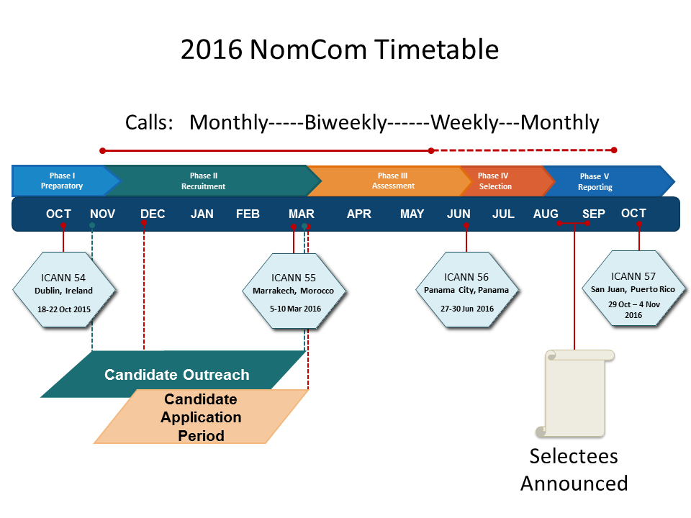

https://www.icann.org/en/system/files/files/nomcom-board-skills-advice-19oct15-en.pdf
“Accomplished persons of integrity, objectivity, and intelligence, with reputations for sound judgment and open minds, and a demonstrated capacity for thoughtful group decision-making;”
http://www.odgersberndtson.de/de/en/

