In response to requests from the GNSO Review Working Party, staff worked with Westlake to revise the GNSO Review Schedule in order to provide the Working Party with additional time to consider Westlake’s Draft Report, prior to public posting. The Structural Improvements Committee has been briefed about the revised schedule.
- GNSO Review Working Party has had ongoing opportunities for substantive input into the GNSO Review process and methodology.
- GNSO Community has had extensive and ongoing opportunities to take part in the 360 Assessment and to offer direct feedback to Westlake in a variety of ways, including via 40 one-on-one interviews (considerably more than originally anticipated in the scope of work), interaction at ICANN meetings and through other communication channels.
- Additionally, community will continue to have multiple touch-points with Westlake and opportunities to share their views via the formal Public Comment process on the Draft Report (1 June – 20 July). 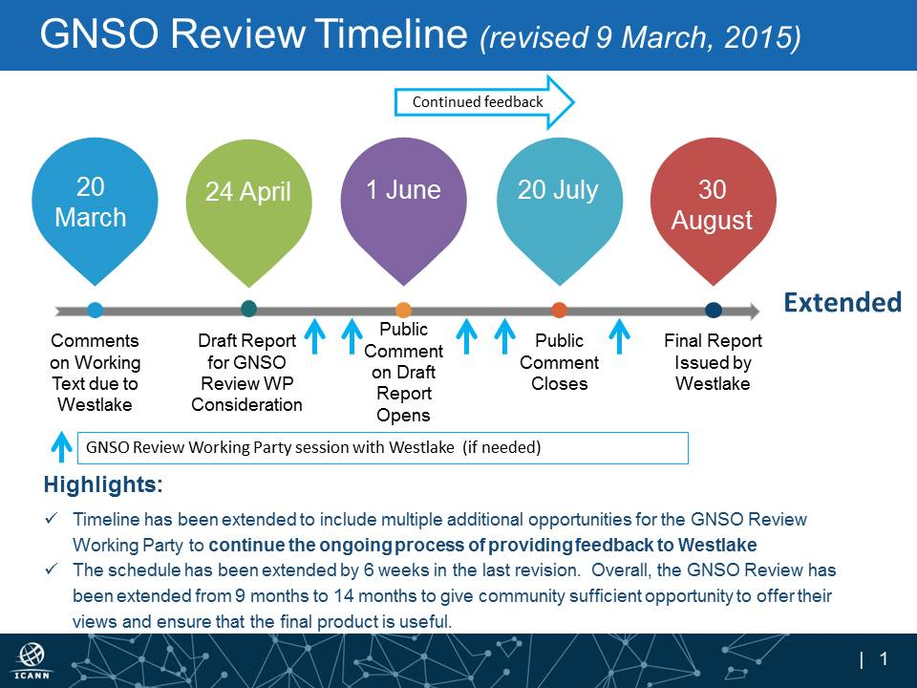
ACTIVITIES AND MILESTONES | OLD DATE | NEW DATE
Update the SIC | 6 February, 2015 | No Change
GNSO Review Working Party Meeting at ICANN52 | 11 February | No Change
GNSO Review Working Party working session | 3 March | No Change
GNSO Review Working Party to deliver comments on Working Text to Westlake | 20 March | No change
Update the SIC | 21 April | 24-26 April
Westlake delivers Draft Report v.0 to GNSO Review Working Party, along with Westlake’s summary of disposition of comments and feedback from GNSO Review Working Party |  | 24 April
GNSO Review Working Party working session with Westlake |  | 4 May
GNSO Review Working Party call (if needed) |  | 12 May
Comments on Draft Report v.0 due from GNSO Review Working Party to Westlake |  | 15 May
Draft Report v.1 from Westlake posted for Public Comment | 23 April - 4 June | 1 June – 20 July
Update the SIC | 19 June | No change
ICANN53 Update GNSO Council, Community | 21 – 26 June | No change
GNSO Review Working Party working session with Westlake |  | TBD during ICANN53
GNSO Review Working Party working session with Westlake (if needed) |  | TBD week of 6 and 27 July
Community review of Report of Public Comments Received (new Public Comment process) | 12 June – 7 July | August 3 – August 17
Final Report | 14 July | August 30

1 June is the deadline for posting information prior to ICANN53.

